

DEPARTMENT OF COMPUTER SCIENCE
AND DATA SCIENCE

IBM FINAL PROJECT
BANK MARKETING PREDICTION
Submitted by
BABY SHALINI.P (222511516)
KAVITHA.D (222511518)

BACHELOR OF SCIENCE IN COMPUTER
SCIENCE WITH DATA SCIENCE

Under the guidance of
Mr.Kavin Chakaravarthi V M- Corporate Trainer

2025 - 2026

DECLARATION

We Kavitha.D and Baby shalini.P . A, hereby declare that this project report on “Bank Marketing Prediction” submitted to the University of Madras in partial fulfillment of the requirement for the award of the Degree Bachelor of Computer Science with Data Science under the Head of guidance Mrs Carolin joshipa ., the depardtment and Mr. Kavin Chakravarthi.vm of has not been submitted earlier to any other university or institute for the award of any degree.
.

Kavitha.D
Baby shalini.P

Place:
Date:

BONAFIDE CERTIFICATE

This is to certify that the project titled “Bank Marketing Prediction” is the bonafide work done by,Kavitha.D and Baby shalini.P. A hereby and first-year student of Jeppiaar College of Arts and Science, Padur, Chennai in partial fulfillment of the requirement for the award of the Degree of Bachelor of Computer Science with Data Science 2025-2026.

PROJECT GUIDE: HEAD OF THE DEPARTMENT:

Mr. Kavin Chakravrthi VM

Date:

S. No | INDEX | Page No
 | Introduction
 | Tools and Technologies Used
3. | Methodology  Requirement Analysis:  Data Preparation:  Dashboard Design:  Testing:  Deployment:
4. | Implementation Details  - HTML Pages:  - Styling:  - Interactive Elements:
5. | Key Feature for the Dashboard
6. | Results And Outcomes
7. | Conclusion
8. | References

1.INTRODUCTION:
In today’s competitive banking environment, marketing campaigns play a crucial role in attracting and retaining customers. Banks often conduct large-scale marketing campaigns using phone calls, emails, and advertisements. However, traditional marketing approaches are costly and frequently result in low success rates due to poor targeting of customers.
Bank marketing prediction involves the use of data analytics and machine learning techniques to predict customer responses to marketing campaigns. By analyzing historical customer data, banks can identify customers who are more likely to subscribe to a product. This allows banks to focus their efforts on high-potential customers, thereby saving time and resources.
The objective of this project is to develop a prediction system and dashboard that provides meaningful insights into customer behavior. The dashboard presents analytical results in a simple and interactive manner, making it easier for bank officials to understand and utilize the predictions for strategic planning.

2.TOOLS AND TECHNOLOGIES USED:
The following tools and technologies were used in the development of this project:
- Python: Used for data analysis and preprocessing
- Libraries: Pandas, NumPy for data handling; Scikit-learn for modeling
- Visualization Tools: Matplotlib and Seaborn
- Frontend Technologies: HTML, CSS, JavaScript
- Development Environment: Jupyter Notebook / Visual Studio Code
- Dashboard Platform: Web-based interactive dashboard
These tools were chosen for their flexibility, performance, and wide acceptance in data analytics and web development.

3.METHODOLOGY:
The project was developed using a structured methodology to ensure clarity, accuracy, and reliability. The methodology consists of five main phases: requirement analysis, data preparation, dashboard design, testing, and deployment.

1.REPQUIREMENT ANALYSIS:
Requirement analysis is the initial phase of the project where the problem and objectives were clearly defined. The primary goal was to predict customer subscription behavior based on historical marketing data. Key requirements identified include:
- Collection and analysis of bank marketing data
- Prediction of customer responses
- Visualization of results through an interactive dashboard
- User-friendly and easy-to-understand interface
This phase helped in defining the scope and limitations of the project.

2.DATA PREPARATION:
Data preparation is a critical step in any data-driven project. The dataset used in this project consists of customer demographic details, financial information, and campaign-related attributes.
The following preprocessing steps were performed:
- Removal of missing and duplicate records
- Encoding of categorical variables
- Normalization of numerical attributes
- Splitting data into training and testing datasets
Proper data preparation ensured improved accuracy and reliability of the predictions.

3.DASHBOARD DESIGN:
The dashboard was designed to provide a clear visual representation of the analyzed data and prediction outcomes. Various charts and graphs were included to display customer distribution, subscription rates, and key influencing factors.
The dashboard layout was designed to be intuitive, allowing users to easily navigate between different sections and gain insights without technical knowledge.

4.TESTING:
Testing was performed to ensure the accuracy and functionality of the system. The testing phase included:
- Verification of data preprocessing steps
- Validation of prediction results
- Testing dashboard interactivity
- Cross-browser compatibility testing
All identified issues were resolved before final deployment.

5.DEPLOYMENT:
The final system was deployed as a web-based dashboard. Deployment ensures that the system can be accessed easily by users and used in real-world scenarios. The deployed dashboard allows real-time interaction with the data and prediction results.

4.IMPLEMENTATION DETAILS:

HTML Pages
HTML was used to create the structure of the dashboard. It includes sections for navigation, visualizations, and data summaries. The layout was designed to be simple and organized.

Styling
CSS was used to enhance the appearance of the dashboard. Styling elements such as fonts, colors, spacing, and alignment were applied to improve readability and user experience. Responsive design principles were followed to ensure compatibility with different screen sizes.

Interactive Elements
JavaScript was used to implement interactive features such as dynamic charts, filters, and user input handling. These features allow users to explore the data and predictions in an interactive manner.

5.CHELLENGES AND SOLUTION:
During the development of the project, several challenges were encountered:
- Handling missing data: Addressed through data cleaning techniques
- Class imbalance: Managed using appropriate evaluation metrics
- Performance issues: Optimized data processing and visualization
- User understanding: Simplified visualizations and explanations
Each challenge was resolved using suitable technical and design approaches.

6.KEY FEATURES OF THE DASHBOARD:
- Visualization of customer demographics
- Prediction of customer subscription likelihood
- Interactive charts and graphs
- Easy navigation and user-friendly interface
- Web-based accessibility

7.RESULT AND OUTCOMES:
The Bank Marketing Prediction Dashboard successfully analyzed customer data and generated meaningful predictions. The results indicate that factors such as campaign duration, previous campaign outcomes, and customer financial status significantly influence subscription decisions.
The dashboard provided actionable insights that can help banks improve marketing strategies, reduce operational costs, and increase customer engagement. Overall, the project achieved its objectives and demonstrated the effectiveness of predictive analytics in banking.

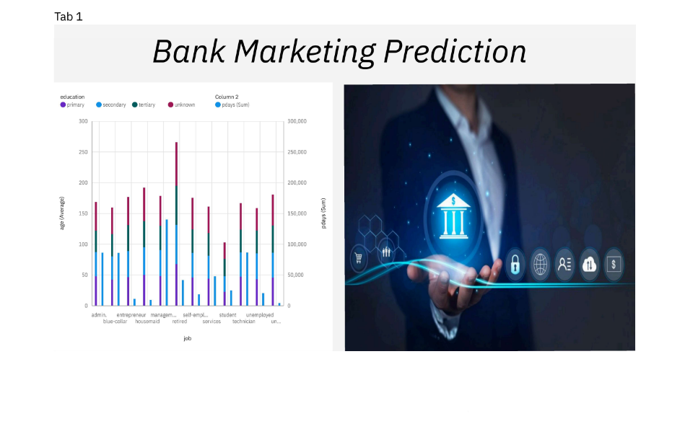

8.CONCLSION:
This project demonstrates the importance of predictive analytics in modern bank marketing. By combining data analysis techniques with an interactive dashboard, the system enables banks to make informed marketing decisions. The project highlights how data-driven approaches can improve efficiency, accuracy, and customer targeting. The developed solution serves as a practical tool for enhancing marketing performance in the
banking sector.

9.FUTURE SCOPE:
The project can be further enhanced in several ways:
- Integration of real-time customer data
- Use of advanced machine learning and deep learning models
- Mobile-responsive dashboard design
- Cloud-based deployment for scalability
- Improved personalization and recommendation features

REFERENCE:

